AI-Based Travel Planner Web Application

20IT6L2- MINI PROJECT - I REPORT
Submitted by
SELVA HARISH J (910623105066)
VIJAY ADHITH A R (910623105085)

In partial fulfillment for the award of the degree of
BACHELOR OF TECHNOLOGY
IN
INFORMATIONTECHNOLOGY

K.L.N. COLLEGE OF ENGINEERING, POTTAPALAYAM
(An Autonomous Institution Affiliated to Anna University, Chennai)
ANNA UNIVERSITY: CHENNAI 600 025
APRIL 2026
BONAFIDE CERTIFICATE
Certified that this Project report “AI-Based Travel Planner Web Application”
is the Bonafide work of “Mr. SELVA HARISH J (910623105066), Mr. VIJAY ADHITH A R (910623105085)” who carried out the project work under my supervision during JANUARY 2026 – MAY 2026.

SIGNATURE SIGNATURE

Dr.P. GANESH KUMAR, M.E., Ph.D., Mrs. S. VIJAYASHARMILA, M.E., (Ph.D).,
PROFESSOR ASSISTANT PROFESSOR
HEAD OF THE DEPARTMENT SUPERVISOR
INFORMATION TECHNOLOGY INFORMATION TECHNOLOGY

K.L.N. COLLEGE OF ENGINEERING K.L.N. COLLEGE OF ENGINEERING
(An ISO 9001-2008 Certified Institution) (An ISO 9001-2008 Certified Institution)
POTTAPALAYAM, SIVAGANGAI, POTTAPALYAM, SIVAGANGAI,
TAMIL NADU, INDIA. TAMIL NADU, INDIA.

Submitted for the Practical Examination held on
Internal Examiner External Examiner

ACKNOWLEDGEMENT

Any work would be unfulfilled without a word of thanks. We hereby take pleasure in acknowledging the persons who guided me through out our work.

First and foremost, thanks are to the omnipotent for providing us with his abundant blessings all throughout. We all extend our heartfelt thanks to Er. K.N.K. KARTHIK,B.E., President of our college and Dr. A.V. RAMPRASAD, M.E., Ph.D., Principal for provisioning us with the all required.

We esteem our self to articulate our sincere thanks to Dr. P.GANESH KUMAR, M.E., Ph.D., Head of the Information Technology for leading us towards the zenith of success.

We express our grateful thanks to our Project Guide Mrs. S. VIJAYASHARMILA, M.E., (Ph.D)., and Project Coordinator Mr. PL SUBRAMANIAN, M.E., (Ph.D)., for their invaluable guidance and motivation. Their assistance and advices had been very helpful throughout our project. I would like to thank all teaching and non-teaching staffs of our department who had been the sources of encouragement and ideas. I thank them for lending their support whenever needed.

ABSTRACT

Travel planning often involves fragmented information, manual budgeting, and inefficient itinerary creation, making the process time-consuming and complex. Travelers typically use multiple platforms to search for destinations, compare accommodations, check routes, and estimate expenses, which can result in poor coordination and budget overruns. AI-Based Travel Planner Web Application that offers complete end-to-end travel planning by analyzing user inputs such as destination, budget, trip duration, and preferences. The system intelligently allocates the budget across transportation, accommodation, and food while recommending suitable hotels, restaurants, and tourist attractions. It integrates map-based services to optimize routes and minimize travel time. Based on location proximity and user priorities, the application generates a structured day-wise itinerary. The proposed solution simplifies travel planning, improves cost accuracy, saves time, and delivers a personalized and efficient travel experience through a single integrated platform.

SUSTAINABLE DEVELOPMENT GOALS

This project supports Sustainable Development Goals such as SDG 9 (Industry, Innovation and Infrastructure) and SDG 4 (Quality Education) by promoting smart, efficient, and technology-driven travel solutions.

TABLE OF CONTENTS
CHAPTER NO | TITLE |  |  | PAGE NO
 | ABSTRACT |  |  | i
 | LIST OF FIGURES |  |  | ii
1 | INTRODUCTION |  |  | 1
 |  | 1.1 Introduction |  | 2
 |  | 1.2 Problem Statement |  | 2
 |  | 1.3 Project Objective |  | 2
 |  | 1.4 Scope of the Project |  | 3
 |  |  | 1.4.1 Existing System | 3
 |  |  | 1.4.2Proposed System | 3
 |  | 1.5 Software Life Cycle Models |  | 3
 |  |  | 1.5.1 Types of Software Lifecycle Models | 5
 |  |  | 1.5.2 Incremental Model | 6
 |  |  | 1.5.3Reason for Choosing Model | 6
2 | LITERATURE REVIEW |  |  | 7
 |  | 2.1 Introduction |  | 8
 |  | 2.2 Literature Review |  | 8
 |  | 2.3 Summary |  | 10
3 | SYSTEM ANALYSIS |  |  | 11
 |  | 3.1 Introduction |  | 12
 |  |  | 3.1.1 Requirement Analysis | 12
 |  |  | 3.1.2 Non-Functional Requirements | 13
 |  |  | 3.1.3 Hardware Requirements | 15
 |  |  | 3.1.4 Software Requirements | 15
 |  | 3.2 Module Description |  | 15
 |  |  | 3.2.1 User Authentication Module | 15
 |  |  | 3.2.2 Trip Input Module | 16
 |  |  | 3.2.3 Budget Analysis Module | 16
 |  |  | 3.2.4 Recommendation Module | 16
 |  |  | 3.2.5 Hotel Details Module | 16
 |  |  | 3.2.6 Itinerary Planner Module | 17
 |  |  | 3.2.7 Final Output Module | 17
4 | SYSTEM DESIGN |  |  | 18
 |  | 4.1 Architecture Diagram |  | 19
 |  | 4.2 Data Flow Diagram |  | 20
 |  | 4.3 UML Diagram |  | 21
 |  |  | 4.3.1 Use Case Diagram | 21
 |  |  | 4.3.2 Class Diagram | 22
 |  |  | 4.3.3 Activity Diagram | 23
 |  |  | 4.3.4 Sequence Diagram | 24
 |  |  | 4.3.5 Component Diagram | 25
5 | IMPLEMENTATION |  |  | 26
 |  | 5.1 Code for the Project |  | 27
6 | TESTING |  |  | 35
 | 6.1 Testing Objectives |  |  | 36
 | 6.2 Process of Testing |  |  | 36
 | 6.3 Software Testing |  |  | 36
 |  | 6.4 Basic Types of Testing |  | 36
 |  |  | 6.4.1 Black Box Testing | 37
 |  |  | 6.4.2 White Box Testing | 37
 |  |  | 6.4.3 Unit Testing | 37
 |  |  | 6.4.4 Integration Testing | 37
 |  |  | 6.4.5 System Testing | 38
 |  |  | 6.4.6 Regression Testing | 38
 |  |  | 6.4.7 Verification and Validation Testing | 38
7 | SCREENSHOTS |  |  | 39
8 | CONCLUSION |  |  | 42
 |  | 8.1 Conclusion |  | 43
 |  | 8.2 Future Enhancement |  | 43
9 | APPENDIX |  |  | 44
10 | REFERENCES |  |  | 47

LIST OF FIGURES
FIGURE NO | FIGURE NAME | PAGE NO
Fig 1.5.1 | Incremental Model | 6
Fig 4.1 | Architecture Diagram of Travel Planner | 19
Fig 4.2 | Data Flow Diagram of Travel Planner | 20
Fig 4.3.1 | Use Case Diagram of Travel Planner | 21
Fig 4.3.2 | Class Diagram of Travel Planner | 22
Fig 4.3.3 | Activity Diagram of Travel Planner | 23
Fig 4.3.4 | Sequence Diagram of Travel Planner | 24
Fig 4.3.5 | Component Diagram of Travel Planner | 35
Fig 7.1 | Screenshot of Main Dashboard | 40
Fig 7.2 | Screenshot of Recommendation Module | 40
Fig 7.3 | Screenshot of Itinerary Module | 41
Fig 7.4 | Screenshot of Trip Output Module | 41

1.INTRODUCTION

INTRODUCTION CHAPTER 1

1.1 INTRODUCTION
Travel planning is often time-consuming and complex as users depend on multiple platforms to search for destinations, hotels, and costs. This makes the process inefficient and difficult, especially for first-time travelers. The AI-Based Travel Planner simplifies this by using artificial intelligence to analyze user inputs such as budget, location, and duration. It generates a personalized, day-wise travel plan with optimized routes and cost estimation. This system saves time, reduces effort, and provides a smart and efficient travel planning solution.

1.2 PROBLEM STATEMENT

Travel planning requires users to search across multiple platforms, making the process time-consuming and confusing. Existing systems provide limited features and do not offer complete, personalized itineraries. This often leads to poor planning and inaccurate cost estimation. Therefore, an intelligent system is needed to automate travel planning and provide efficient, budget-based solutions.

1.3 PROJECT OBJECTIVE

The objective of this project is to develop an AI-Based Travel Planner that automates travel planning. It generates personalized day-wise itineraries based on user inputs like budget, location, and duration. The system also provides cost estimation and optimized routes to improve efficiency and user experience.

1.4 SCOPE OF THE PROJECT

1.4.1 EXISTING SYSTEM
The existing travel planning system relies on multiple applications such as maps, hotel booking sites, and travel guides. These platforms provide only partial information and lack integration. Users must manually search, compare, and organize their plans, which is time-consuming and inefficient. Additionally, existing systems do not provide personalized, budget-based itineraries.

1.4.2 PROPOSED SYSTEM
The proposed system is an AI-Based Travel Planner that provides an integrated solution for travel planning. It collects user inputs such as location, budget, number of days, and preferences to generate personalized travel plans. The system recommends tourist places, hotels, and transportation options using intelligent algorithms. It also estimates the total cost by considering expenses for travel, accommodation, and food. A route optimization feature helps in selecting the shortest and most efficient paths. Finally, the system generates a structured day-wise itinerary, reducing manual effort and improving user experience.

1.5 SOFTWARE LIFE CYCLE MODELS

SOFTWARE LIFE CYCLE
The period of time that start when a software is conceived and end when the product no longer available for use. The Software Life Cycle typically
includes :
- Requirement phase
- Design phase
- Implementation phase
- Test phase
- Installation and checkout phase
- Operation and maintenance phase

REQUIREMENT PHASE
The requirement phase focuses on understanding the exact needs of the customer and documenting them clearly. During this stage, both functional and non-functional requirements are collected through discussions with stakeholders. Proper communication helps remove ambiguity and ensures clarity. Feasibility analysis is also carried out to check whether the project is technically and financially viable. Finally, all gathered information is compiled into a requirement specification document for future reference.

DESIGN PHASE

The design phase aims to convert the requirements into a structured system design suitable for implementation. In this stage, the overall system architecture is defined along with detailed design components. High-level and low-level designs are prepared to guide developers. Decisions regarding data structures, algorithms, and interfaces are made. The design ensures that the system will be scalable, efficient, and easy to maintain.

IMPLEMENTATION PHASE
In the implementation phase, the design is translated into actual code using a programming language. Developers create different modules of the system based on the design documents. Coding standards and best practices are followed to maintain quality and consistency. Each module is developed and tested individually through unit testing. Initial debugging is also performed to remove basic errors.

TEST PHASE
The test phase ensures that the developed system meets customer requirements. Various testing methods such as unit testing, integration testing, system testing, and acceptance testing are conducted. Test cases are designed to identify defects and ensure proper functionality. Any errors found are corrected by modifying the code. This phase is essential to deliver a reliable and error-free system.

INSTALLATION AND CHECKOUT PHASE
This phase involves installing the developed system at the user’s site and making it ready for use. The system is configured according to the user’s environment and requirements. Acceptance testing is performed to verify that all requirements are satisfied. Users are also trained to operate the system effectively. Once approved, the system is officially deployed for real-world use.

OPERATION AND MAINTENANCE PHASE
The operation and maintenance phase focuses on keeping the software functional and up-to-date over time. This phase may last for many years after development is completed. It includes correcting errors, improving performance, and adding new features. Obsolete components are removed to keep the system efficient. Continuous monitoring and updates ensure the long-term success of the software.

1.5.1 TYPES OF SOFTWARE LIFECYCLE MODEL
The common lifecycle models are
- Spiral model
- Waterfall model
- Throwaway prototyping model
- Evolutionary prototyping model

- Incremental/iterative development
- WIN/WIN Spiral model

1.5.2 INCREMENTAL MODEL
The incremental model in software development is an iterative and flexible approach that breaks down the project into smaller, manageable segments or increments. Each increment represents a portion of the software's functionality and can be developed, tested, and delivered independently. Unlike traditional waterfall models, where the entire project is completed in a single phase, the incremental model allows for the continuous addition of features or improvements over time.
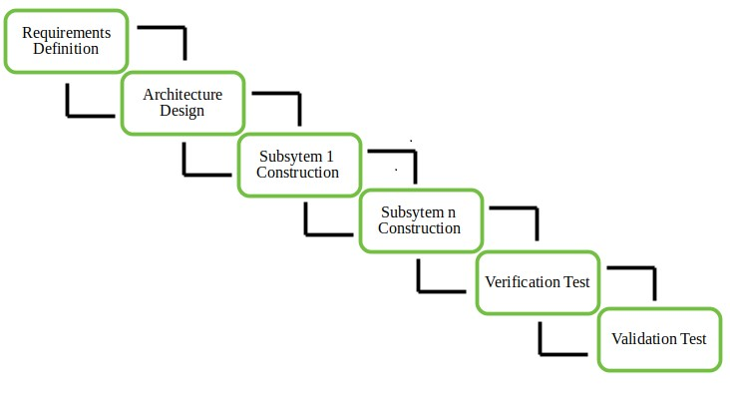
Figure 1.5.1 Incremental model
1.5.3 REASON FOR CHOOSING THIS MODEL
- Easy to develop in small parts
- Early testing and error fixing
- Flexible to add new features

2.LITERATURE REVIEW

LITERATURE REVIEW CHAPTER 2

2.1 INTRODUCTION

The literature review has been carried out to understand the various technologies and methods used in travel planning systems. With the growth of digital platforms and Artificial Intelligence (AI), travel planning has evolved from manual methods to intelligent and automated systems. This review focuses on existing travel applications, recommendation systems, and AI-based solutions that help in improving travel planning efficiency and user experience.
2.2 LITERATURE REVIEW

[1] J. Lee, M. Chen, “Deep Learning Based Intelligent Travel Planner”, IEEE Access, 2026.
The proposed system uses deep learning techniques to enhance travel planning by analyzing large volumes of user data, including travel history, preferences, seasonal variations, and real-time conditions. It provides personalized recommendations for tourist destinations, accommodations, and activities. The system adapts over time by learning user behavior, improving the accuracy of suggestions. It also integrates external data sources such as weather and traffic to improve planning efficiency. However, the system mainly focuses on recommendation and lacks a fully structured day-wise itinerary. Additionally, it does not strictly manage budget allocation, making it less suitable for users who require precise cost control.

[2] A. Sharma, R. Gupta, “AI-Driven Travel Planning and Recommendation System”, International Journal of Advanced Computer Science, 2025.
This system utilizes Artificial Intelligence and machine learning algorithms to generate travel recommendations based on user inputs such as budget, interests, and travel duration. It suggests suitable tourist places, hotels, and activities, improving the overall travel experience. The system enhances personalization by analyzing user preferences and patterns. Despite its advantages, it primarily focuses on recommendation and lacks full automation in travel planning. It does not provide a detailed day-wise itinerary or optimize routes and expenses effectively, which limits its usefulness for complete trip planning.

[3] Google, “Google Maps Platform – Route Optimization and Distance Matrix API,” vol. 1, 2025.
Google Maps Platform provides advanced features such as route optimization, navigation, and distance calculation between locations. It uses real-time traffic data and efficient algorithms to determine the shortest and fastest routes. This helps users reduce travel time and improve navigation accuracy. The platform also supports multiple location mapping and travel time estimation. However, it is limited to navigation services and does not offer integrated travel planning features such as itinerary generation, budget estimation, or personalized recommendations. Users must rely on additional platforms to complete their travel planning process.

[4] MakeMyTrip, “AI-Powered Travel Booking and Planning System”, 2025.
MakeMyTrip is a widely used travel platform that offers booking services for hotels, flights, and travel packages. It uses AI-based techniques to provide personalized suggestions based on user preferences and past searches. The system provides detailed information about pricing, availability, and user reviews, helping travelers make informed decisions. However, the platform focuses mainly on booking services and does not provide complete travel planning functionality. It lacks features such as automated itinerary generation, route optimization, and budget distribution, requiring users to manually organize their travel plans.

[5] K. Patel, R. Iyer, “Automated Budget-Based Travel Planning System using AI”, International Journal of Emerging Technologies, 2025.

This system focuses on budget-based travel planning by using AI algorithms to allocate expenses across transportation, accommodation, and food. It ensures that the travel plan remains within the user’s budget, making it useful for cost-conscious travelers. The system provides recommendations based on financial constraints and user preferences. However, it has limitations in route optimization and real-time data integration. It also does not generate a complete day-wise itinerary, which is essential for structured and efficient travel planning.

2.3 SUMMARY
The above literature review highlights that existing systems provide useful features such as recommendations, booking services, and route optimization. However, they lack integration, personalized itinerary generation, and accurate budget planning. Most systems require users to combine information from multiple sources, making the process inefficient. The proposed AI-Based Travel Planner aims to overcome these limitations by providing a complete, automated, and budget-based travel planning solution.

3.SYSTEM ANALYSIS
SYSTEM ANALYSIS CHAPTER 3

3.1 INTRODUCTION

This chapter provides a detailed description of the requirements of the AI Travel Planner Web Application. The requirements are categorized into functional requirements and non-functional requirements, which define the behavior, performance, and usability of the system.

3.1.1 REQUIREMENT ANALYSIS

FUNCTIONAL REQUIREMENTS
INPUT
The system takes input from the user through a web interface during the trip planning process. The required inputs include:
- Destination
- Budget
- Number of days
- Travel type (solo, family, friends)

PROCESS
Based on the user input, the system performs the following operations:
- Analyzes the user’s budget and divides it into categories such as hotel, food, transportation, and tourist activities
- Generates personalized recommendations for hotels, restaurants, and tourist spots
- Filters options based on budget constraints and user preferences
- Arranges tourist locations in an optimized visiting order
- Integrates map-based location data for better navigation

OUTPUT
The system provides the following outputs to the user:
- Budget breakdown (hotel, food, travel, tickets)
- Recommended hotels, restaurants, and tourist spots (up to 3 choices each)
- Detailed hotel information with contact and map location
- Day-wise travel itinerary with ordered tourist spots
- External links for booking and navigation

3.1.2 NON-FUNCTIONAL REQUIREMENTS
USER FRIENDLY
The system is designed with a simple and intuitive interface that allows users to interact with it easily without requiring technical knowledge. Clear navigation, well-organized features, and user-centric design make trip planning straightforward. Even first-time users can quickly understand how to use the application. The interface minimizes complexity and enhances usability. This ensures a smooth and comfortable experience for all types of users.

PLATFORM INDEPENDENT
The application is web-based and can run on any platform that supports a web browser. It is compatible with popular browsers such as Google Chrome, Microsoft Edge, and Firefox. This makes the system accessible across different devices including desktops, laptops, tablets, and smartphones. Users do not need to worry about operating system limitations. As a result, the application provides flexibility and convenience.

EASE OF USE
Since the system is web-based, it does not require any installation and can be accessed anytime and anywhere with an internet connection. The application provides an interactive user interface that guides users step by step. Features are designed to be simple and easy to understand. This reduces the learning curve for new users. Overall, the system enhances user experience through accessibility and simplicity.

SECURITY
The system ensures the protection of user data by implementing strong security measures. Sensitive information such as login credentials and personal preferences are stored securely. Authentication mechanisms are used to verify user identity. Encryption techniques help prevent unauthorized access and data breaches. This ensures that user information remains safe and confidential.

RELIABILITY
The application is designed to deliver consistent performance under different conditions. It provides dependable results based on user inputs without frequent errors or failures. The system is tested thoroughly to ensure stability. Users can rely on it for accurate travel planning and recommendations. This consistency builds trust and improves user satisfaction.

ACCURACY
The system provides accurate results by analyzing user input effectively. The recommendation engine generates realistic travel plans and budget estimates. It considers various factors to improve precision in suggestions. This helps users make better decisions while planning their trips. Accurate outputs increase the usefulness and credibility of the application.

RESPONSE TIME
The system is optimized to process user requests quickly and efficiently. It generates results in a short amount of time to avoid delays. Fast response improves user interaction and satisfaction. Even with multiple inputs, the system maintains good performance. This ensures a smooth and seamless user experience.
SCALABILITY
The application is designed to handle an increasing number of users without affecting performance. It can support multiple users simultaneously. The system architecture allows easy addition of new features such as AI-based recommendations and booking integration. It can grow according to user demands. This makes the application future-ready and adaptable.

3.1.3 HARDWARE REQUIREMENTS
The system does not require any specialized hardware to operate efficiently. It can run on basic devices such as a computer, laptop, or smartphone. An active internet connection is necessary to access the web-based application. Additionally, a standard web browser is required for interaction with the system. These minimal requirements make the application easily accessible to a wide range of users.

3.1.4 SOFTWARE REQUIREMENTS
The system is developed using a combination of modern web technologies. The frontend is built using HTML, CSS, and JavaScript, with optional use of frameworks like React.js for enhanced user interface design. The backend is implemented using Node.js and Express.js to handle server-side logic. For data storage, databases such as MongoDB or MySQL are used. The application also integrates APIs like Google Maps API for location and navigation features. Development tools such as Visual Studio Code (VS Code) are used for coding and project management.

3.2 MODULE DESCRIPTION
3.2.1 USER AUTHENTICATION MODULE
The user authentication module allows users to securely register and log in to the system. It manages user credentials and stores data in a protected manner. Authentication mechanisms ensure that only authorized users can access the system. The module also provides session management to maintain user login status. This enhances both security and user experience.

3.2.2 TRIP INPUT MODULE
The trip input module is responsible for collecting travel-related information from users. It gathers details such as destination, budget, and number of travel days. The module ensures that all inputs are valid and complete before processing. Input validation helps prevent errors and improves system accuracy. This module acts as the starting point for generating travel plans.

3.2.3 BUDGET ANALYSIS MODULE
The budget analysis module processes the user’s budget and divides it into different categories such as accommodation, food, and transportation. It helps users understand how their budget is allocated. The system presents this information using visual elements like charts or cards. This improves clarity and decision-making. It ensures users can plan trips within their financial limits.

3.2.4 RECOMMENDATION MODULE
The recommendation module suggests suitable options for hotels, restaurants, and tourist attractions. It analyzes user preferences and constraints to provide relevant results. The system typically displays up to three optimized choices for each category. This helps users quickly compare and select the best options. It enhances the overall planning experience.

3.2.5 HOTEL DETAILS MODULE
The hotel details module provides comprehensive information about selected hotels. It includes details such as location, pricing, and available facilities. The system integrates map features to show the exact location of the hotel. It may also include contact information and booking links. This helps users make informed accommodation decisions.
3.2.6 ITINERARY PLANNER MODULE
The itinerary planner module organizes tourist destinations into an efficient travel schedule. It creates a day-wise plan based on user inputs and preferences. The module optimizes routes to reduce travel time and improve convenience. It ensures that users can visit maximum places within their available time. This results in a well-structured and enjoyable travel plan.

3.2.7 TRIP OUTPUT MODULE
The trip output module presents the complete travel plan to the user. It displays all selected options including budget breakdown, itinerary, and recommendations. Users can review and modify their choices if needed. The module also provides options to download or share the itinerary. This ensures flexibility and usability of the final plan.

4.SYSTEM DESIGN

SYSTEM DESIGN CHAPTER 4

4.1 ARCHITECTURE DIAGRAM
The User interacts with the web application to log in and enter trip details. The frontend sends requests to the backend server, which processes data and communicates with the recommendation engine and database. The system analyzes the budget and generates personalized suggestions for hotels, restaurants, and tourist spots. External APIs are used for maps and travel information. Finally, the complete itinerary and travel plan are displayed to the user.
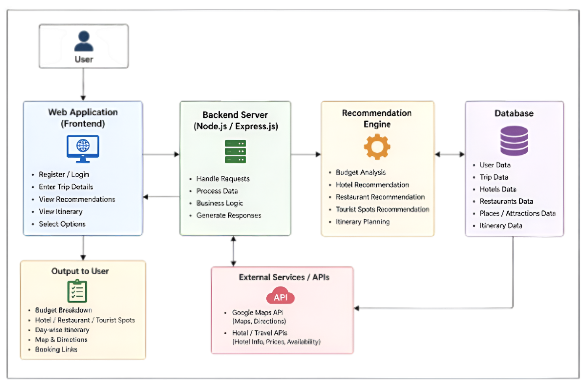
Figure 4.1 Architecture diagram of Travel Planner

4.2 DATA FLOW DIAGRAM
The User logs in and enters trip details such as destination, budget, and preferences. The system analyzes the budget and checks if it is sufficient, suggesting adjustments if needed. Once valid, it generates top recommendations for hotels, restaurants, and places. The user selects options, and the system creates a day-wise itinerary. Finally, the complete travel plan is displayed.
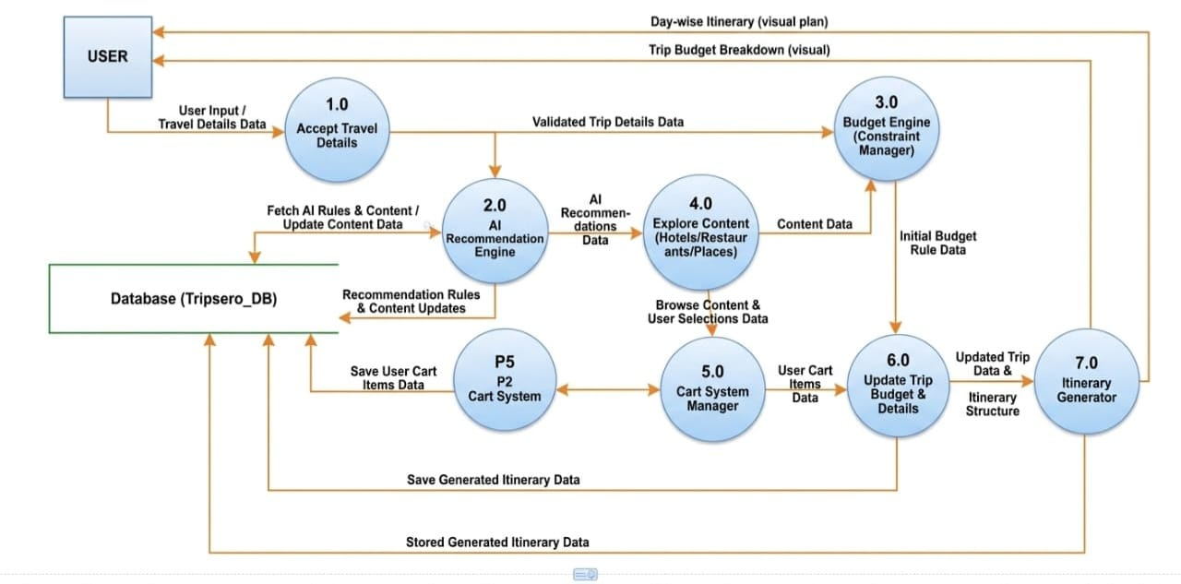
Figure 4.2 Data flow diagram of Travel Planner

4.3 UML DIAGRAM
Unified Modeling Language (UML) is a standardized modeling language used in software engineering for visualizing, specifying, constructing, and documenting the components of a software system.

4.3.1 USE CASE DIAGRAM
A use case diagram illustrates the interactions between external actors and the system, showing how users interact with the system and its main functions.

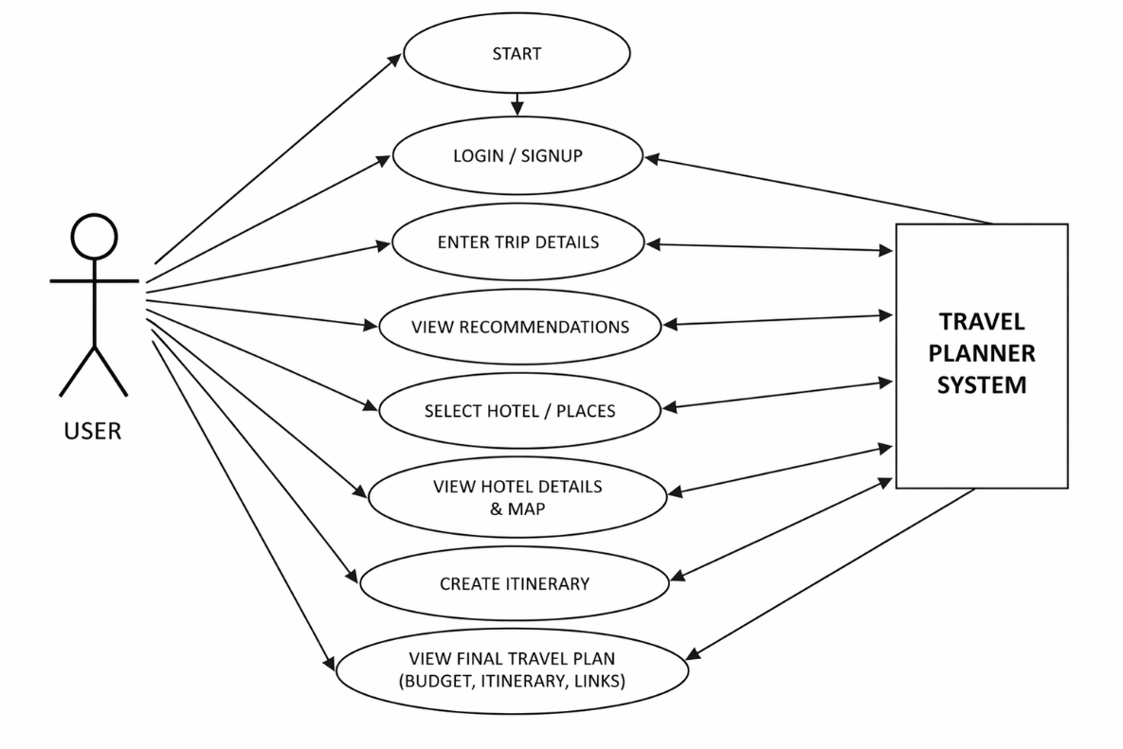
Figure 4.3.1 Use case diagram of Travel Planner

4.3.2 CLASS DIAGRAM
This diagram shows the overall architecture of the AI Travel Planner system and how different modules are connected. It includes main components such as User, Trip, Recommendation, Cart, Payment, Itinerary, and Final Output, which interact through a central Database for data storage and management. The MapsService module is used for route and location information using external map services. Each module performs specific tasks like trip planning, budgeting, recommendations, and itinerary generation. Overall, the diagram explains how all parts of the system work together to provide a complete travel planning solution.

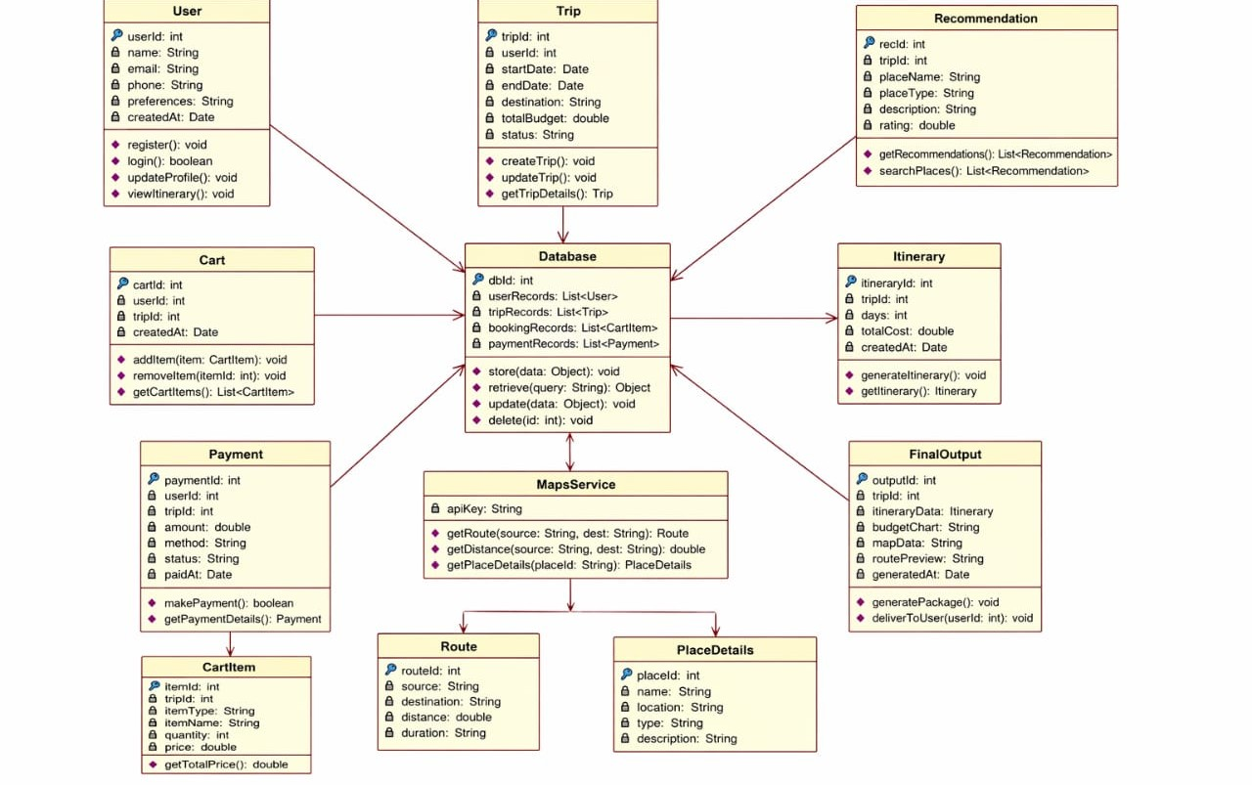

Figure 4.3.2 Class diagram of Travel Planner

4.3.3 ACTIVITY DAIGRAM
The User starts by logging into the system and entering trip details such as destination, budget, and travel preferences. The system analyzes the budget and checks if it is sufficient for the planned trip. If not, it suggests adjustments; otherwise, it generates suitable recommendations. The user selects preferred options, and the system creates a day-wise itinerary. Finally, the complete travel plan is displayed to the user.
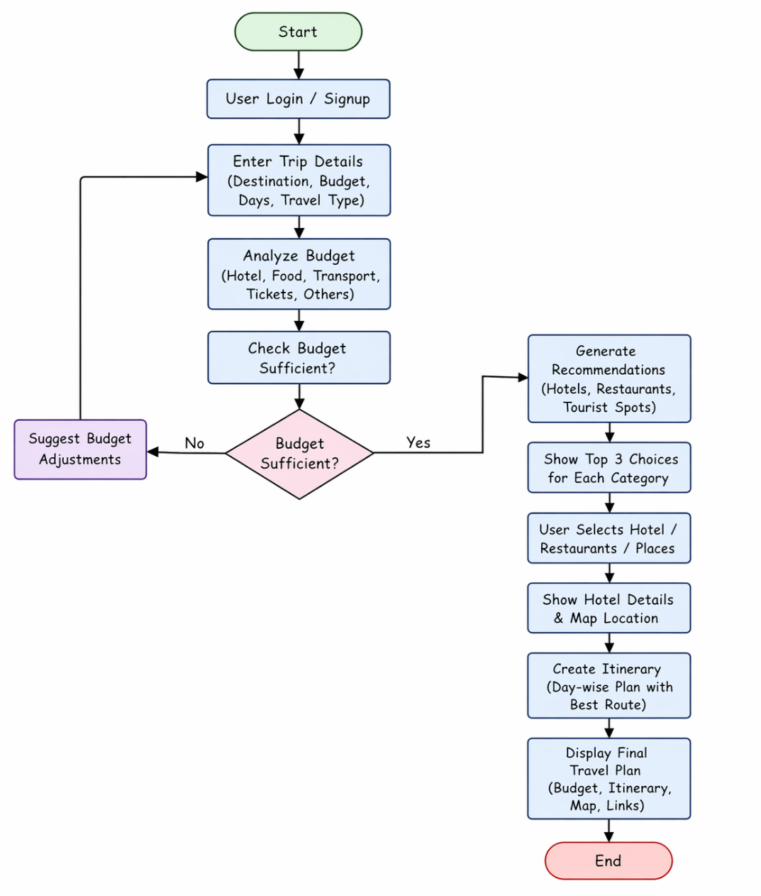
Figure 4.3.3 Activity diagram of Travel Planner

4.3.4 SEQUENCE DIAGRAM
The User is the main actor who interacts with the AI Travel Planner to organize trips. They log in and enter trip details like destination, budget, and preferences. The system provides personalized recommendations based on this input. The user selects options and customizes the plan. Finally, a complete travel itinerary is generated.

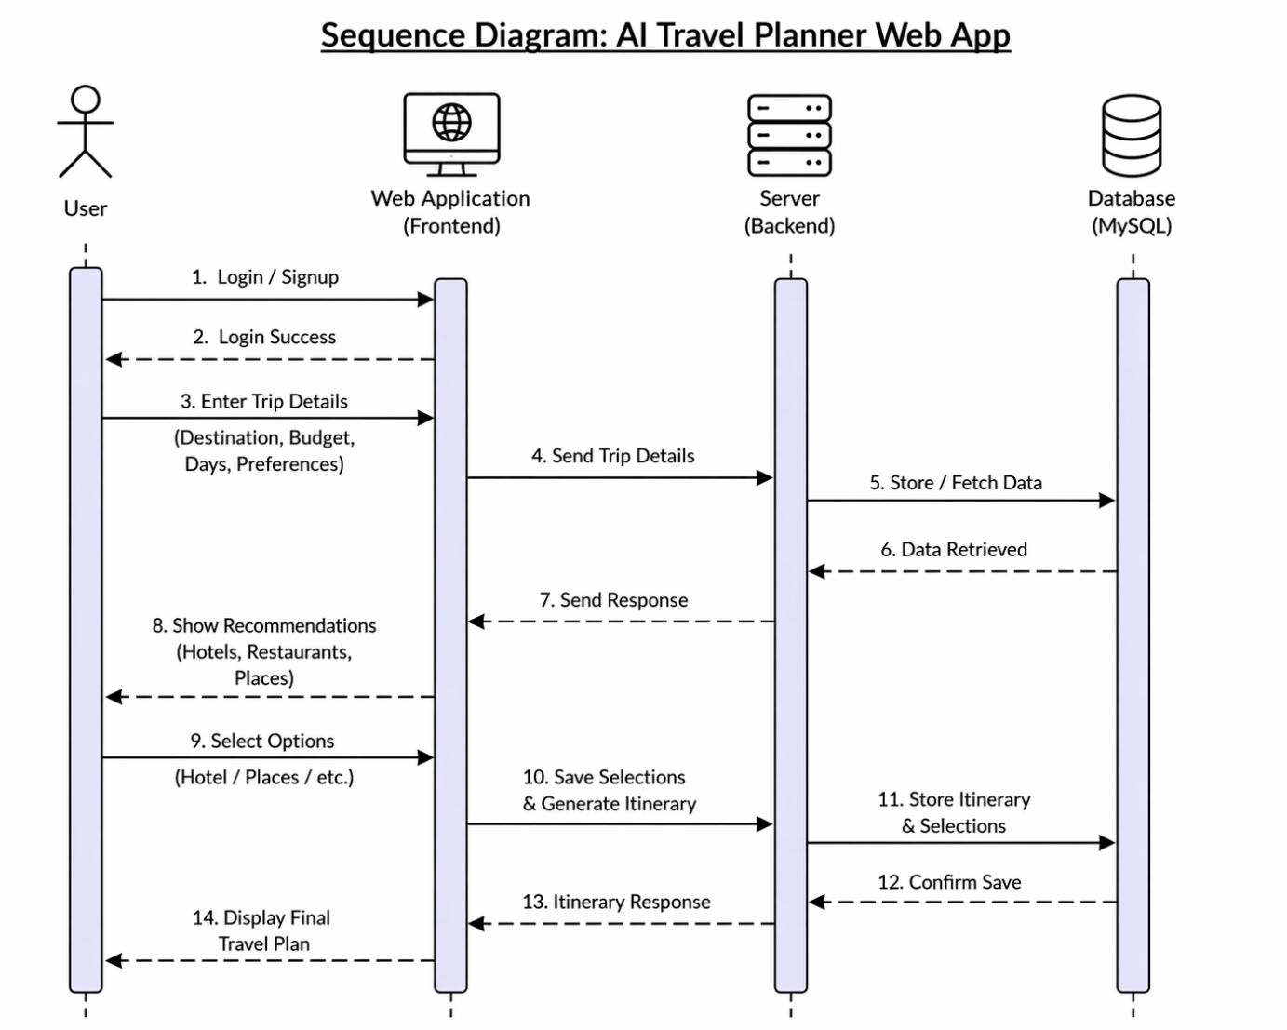

Figure 4.3.4 Sequence diagram of Travel Planner

4.3.5 COMPONENT DIAGRAM
The Component diagram shows an AI Travel Planner web app with frontend, backend, and database.The frontend allows login, trip input, recommendations, and itinerary viewing.The backend handles authentication, trip processing, and AI-based recommendations.It connects to external APIs like maps, hotels, and restaurants for real-time data.All user and trip details are stored in a MySQL database.
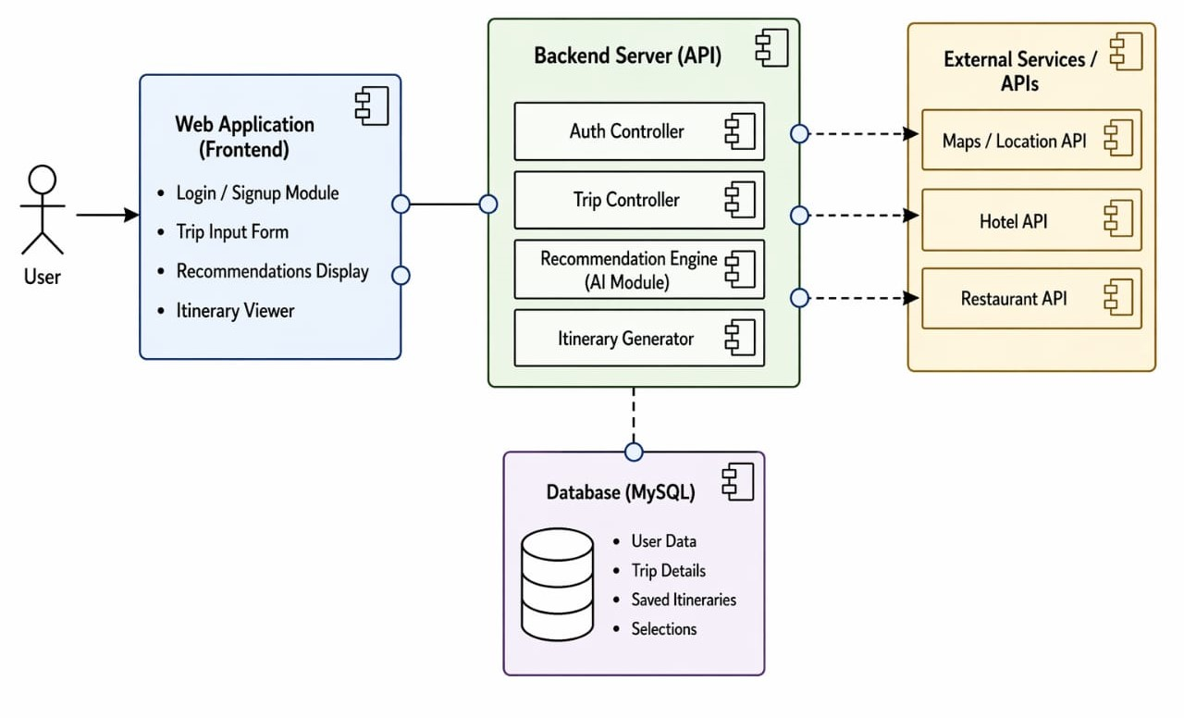

Figure 4.4.5 Component diagram of Travel Planner

5.IMPLEMENTATION

IMPLEMENTATION CHAPTER 5
5.1 CODE FOR THE PROJECT
<!DOCTYPE html>
<html lang="en">
<head>
<meta charset="UTF-8">
<meta name="viewport" content="width=device-width, initial-scale=1.0">
<title>Tripsero - Your Next Escape</title>
<link rel="stylesheet" href="../global.css">
<link rel="stylesheet" href="../index.css">
<link href="https://cdnjs.cloudflare.com/ajax/libs/font-awesome/6.0.0/css/all.min.css" rel="stylesheet">
<link href="https://fonts.googleapis.com/css2?family=Plus+Jakarta+Sans:wght@400;500;600;700;800&display=swap" <link
rel="stylesheet" href="https://cdn.jsdelivr.net/npm/flatpickr/dist/flatpickr.min.css">
<link rel="stylesheet" type="text/css" href="https://npmcdn.com/flatpickr/dist/themes/material_green.css">
</head>
<body data-page="home">
<!-- Hero Section with Background -->
<section class="hero-wrapper">
<!-- Navigation -->
<nav class="glass-nav">
<div class="container nav-content">
<a href="#" class="logo">
<div class="logo-icon"><i class="fa-solid fa-paper-plane"></i></div>
<span>Tripsero</span>
</a>
<div class="nav-links">
<a href="#" class="active">Home</a>
<a href="../hotels.html">Explore</a>
<a href="../tripcart.html">My Trip</a>
<a href="../chat.html" style="color: #22c55e; font-weight: bold;"><i class="fa-solid fa-sparkles"></i> AI Planner</a>
<a href="../settings.html">Settings</a>
<a href="#">About us</a>
</div>
<div class="nav-actions">
<a href="../login.html" class="btn-signup">Login / Sign Up</a>
</div>
</div>
</nav>
<!-- Main Hero Content -->
<div class="container hero-center">
<h1 class="hero-title">
Explore the world,<br>AI-style.
</h1>
<p class="hero-subtext">
Tell us your preferences and we'll craft the perfect itinerary in seconds.
</p>
<!-- Search Bar Container -->
<div class="search-container-bottom">
<form class="main-search-bar" id="tripForm">
<!-- Destination -->
<div class="search-field">
<div class="icon-section">
<i class="fa-solid fa-location-dot"></i>
</div>
<div class="field-content">
<label>DESTINATION</label>
<input type="text" id="destination" placeholder="Where to?" required>
</div>
</div>
<div class="v-divider"></div>
<!-- Budget -->
<div class="search-field">
<div class="icon-section">
<i class="fa-solid fa-money-bill-wave"></i>
</div>
<div class="field-content">
<label>BUDGET</label>
<select id="budget">
<option value="50000">Budget</option>
<option value="200000" selected>Midrange</option>
<option value="500000">Luxury</option>
</select>
</div>
</div>
<div class="v-divider"></div>
<!-- Date Picker (Hidden trigger) -->
<div class="search-field date-picker-wrapper">
<div class="icon-section">
<i class="fa-regular fa-calendar-check" id="calendarIcon" style="cursor: pointer;"></i>
</div>
<div class="field-content">
<label>DATES</label>
<input type="text" id="dateRange" placeholder="Select dates" readonly required>
</div>
</div>

<button type="submit" class="search-btn">
Plan My Trip <i class="fa-solid fa-sparkles"></i>
</button>
</form>
</div>
</div>
</section>
<script src="https://cdn.jsdelivr.net/npm/flatpickr"></script>
<script src="../database.js"></script>
<script src="../app.js"></script>
<script>
// Initialize Flatpickr
const fp = flatpickr("#dateRange", {
mode: "range",
minDate: "today",
dateFormat: "Y-m-d",
altInput: true,
altFormat: "M j, Y",
onClose: function (selectedDates, dateStr, instance) {
if (selectedDates.length === 2) {
const diffTime = Math.abs(selectedDates[1] - selectedDates[0]);
const diffDays = Math.ceil(diffTime / (1000 * 60 * 60 * 24)) + 1;
instance.altInput.value = `${instance.formatDate(selectedDates[0], "M j")} - ${instance.formatDate(selectedDates[1], "M j")} (${diffDays} days)`;
}
}
});

// Trigger calendar on icon click
document.getElementById('calendarIcon').addEventListener('click', () => {
fp.open();
});
// Handle form submission
document.getElementById('tripForm').addEventListener('submit', function (e) {
e.preventDefault();
// Authentication Guard
if (!Auth.isLoggedIn()) {
TripPlanner.showNotification('Please login or sign up to start planning!', 'warning');
setTimeout(() => {
window.location.href = '../login.html';
}, 1500);
return;
}
const destination = document.getElementById('destination').value;
const dates = fp.selectedDates;

if (dates.length < 2) {
TripPlanner.showNotification('Please select a date range!', 'error');
return;
}
const startDate = dates[0].toISOString().split('T')[0];
const endDate = dates[1].toISOString().split('T')[0];
const diffTime = Math.abs(dates[1] - dates[0]);
const duration = Math.ceil(diffTime / (1000 * 60 * 60 * 24)) + 1;
const budgetValue = parseInt(document.getElementById('budget').value) || 50000;
const budgetText = document.getElementById('budget').options[document.getElementById('budget').selectedIndex].text;
const tripData = {
destination: destination,
budget: budgetValue,
budgetType: budgetText,
travelers: 2,
duration: duration,
startDate: startDate,
endDate: endDate,
preferences: 'all'
};
// Clear previous selections for a fresh start
TripPlanner.clearCart();
// Save to localStorage
TripPlanner.saveTripData(tripData);
// Redirect to loading page
window.location.href = '../loading.html';
});
</script>
</body>
</html>

6.TESTING

TESTING CHAPTER 6

6.1 TESTING OBJECTIVES
- Testing is a process of executing software with the intent of finding errors.
- Good testing has a high probability of finding as -yet- undiscovered errors.
- Successful testing discovers unknown errors.
- If did not find any errors, need to ask whether our testing approach is good.

6.2 PROCESS OF TESTING
Testing is the process of evaluating a software product to determine whether it contains any defects and to ensure that it meets the specified requirements. It involves executing the system with the intent of identifying errors, gaps, or missing functionalities. Testing helps improve the quality, reliability, and performance of the application. It also ensures that the system behaves as expected under different conditions.

6.3 SOFTWARE TESTING
Software Testing is a process of evaluating a system by manual or automatic means and verify that it satisfies specified requirements or identify differences between expected and actual results.

6.4 BASIC TYPES OF TESTING
- Black Box Testing
- White Box Testing
- Unit Testing
- Integration Testing
- System Testing
- Regression Testing
- Verification and Validation Testing

6.4 TESTING TECHNIQUES USED

6.4.1 Black Box Testing
Black box testing is a method of testing where the internal structure or code of the application is not known to the tester. The tester focuses only on input and output to verify whether the system behaves as expected. It is used to check functionality based on requirements. This type of testing ensures that the system meets user expectations. It is commonly used in system and acceptance testing.

6.4.2 White Box Testing
White box testing involves testing the internal structure, logic, and code of the application. The tester has knowledge of the source code and verifies the flow of data and control. It helps in identifying logical errors, loops, and code inefficiencies. This testing ensures that all code paths are executed properly. It is mainly performed by developers during the development phase.

6.4.3 UNIT TESTING:
Unit testing focuses on testing individual components or modules of the system separately. Each unit is tested to ensure it performs its intended function correctly. It helps in identifying bugs at an early stage of development. Developers usually write test cases for each unit. This improves code quality and simplifies debugging.

6.4.4 INTEGRATION TESTING
Integration testing is used to verify the interaction between different modules of the system. After individual units are tested, they are combined and tested as a group. It helps identify issues related to data flow and communication between modules. This testing ensures that integrated components work together smoothly. It reduces the chances of system failure due to module interaction issues

6.4.5 System Testing
System testing involves testing the complete and fully integrated application. It checks whether the system meets all specified requirements. This testing is performed in an environment similar to the real-world scenario. It evaluates the overall functionality, performance, and reliability of the system. It ensures the system is ready for deployment.

6.4.6 Regression Testing
Regression testing is performed to ensure that new changes or updates do not affect the existing functionality of the system. Whenever modifications are made, previously tested features are re-tested. It helps in detecting any unintended side effects. This ensures stability and consistency of the application. It is an important part of maintenance and updates.

6.4.7 Verification and Validation Testing
Verification and validation testing ensure that the system is built correctly and meets user needs. Verification checks whether the product is developed according to specifications. Validation ensures that the final product fulfills its intended purpose. Together, they confirm both correctness and usefulness of the system. This helps in delivering a high-quality and reliable product.

7.SCREENSHOTS

SCREENSHOTS CHAPTER 7

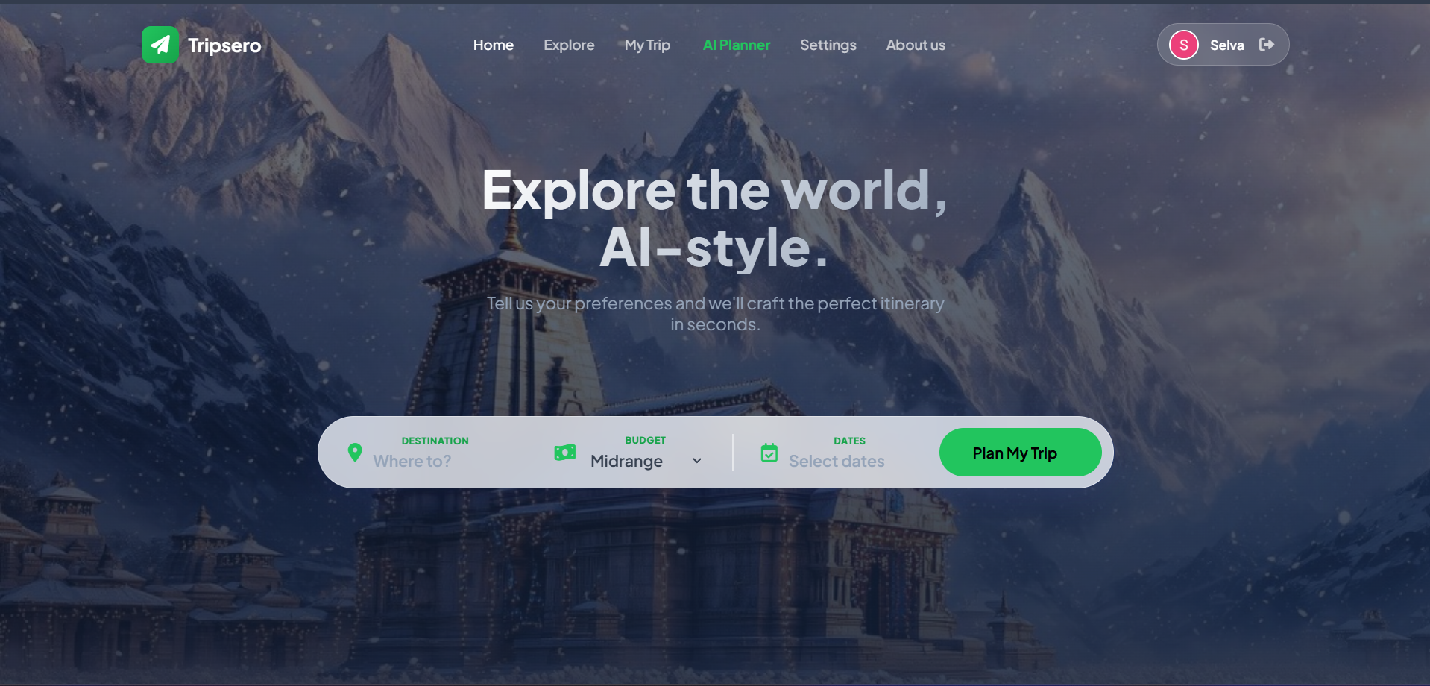

Fig 7.1 Screenshot of Main Dashboard

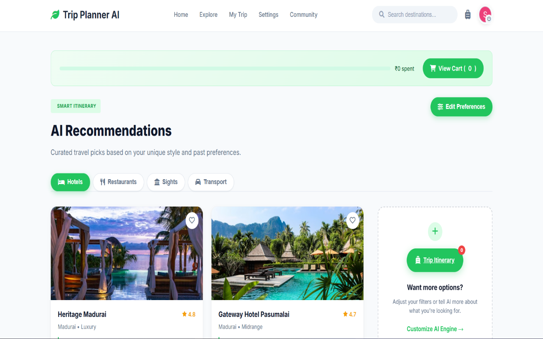

Fig 7.2 Screenshot of Recommendation module

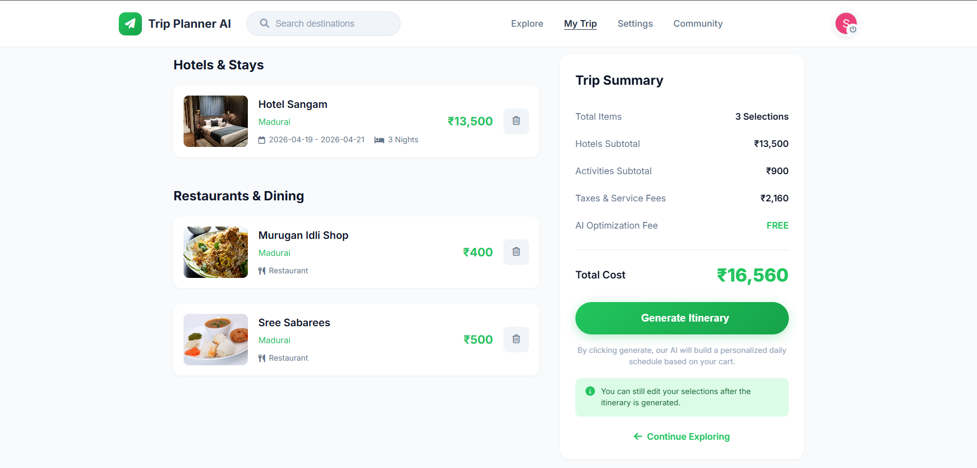

Figure 7.3 Screenshot of Itinerary module
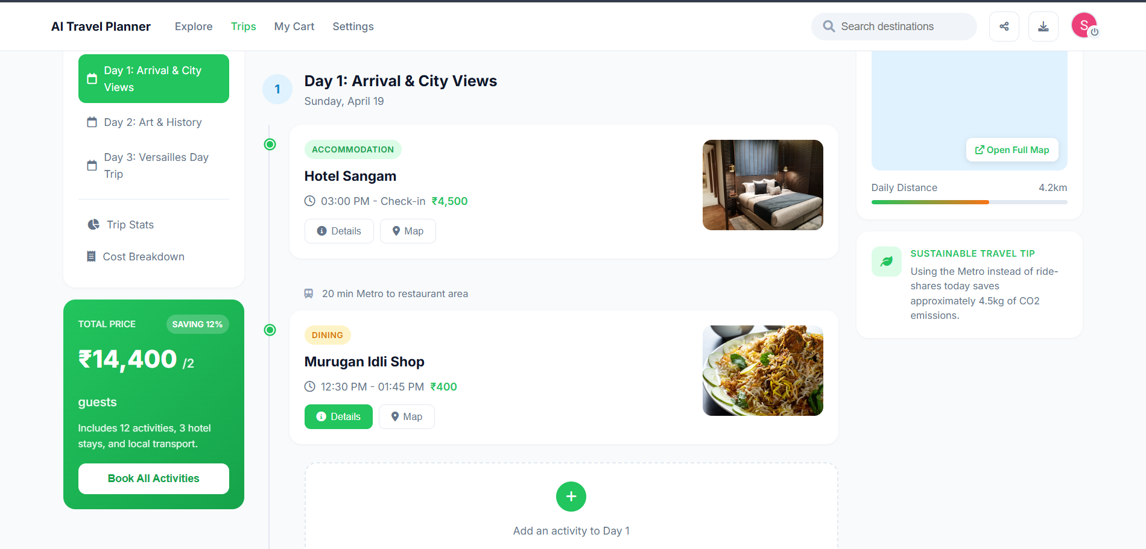

Figure 7.4 Screenshot of Trip Output Module

8.CONCLUSION

CONCLUSION CHAPTER 8

8.1 CONCLUSION

The AI Travel Planner Web Application is an innovative solution designed to simplify and enhance the travel planning experience for users. This system provides an intelligent and user-friendly platform where users can efficiently plan their trips based on their budget, preferences, and duration.With features such as budget analysis, personalized recommendations, hotel details, and itinerary generation, the application eliminates the need to visit multiple platforms. It ensures better decision-making by presenting optimized travel plans, reducing both time and effort.The integration of smart recommendation systems and map-based navigation significantly improves the overall travel experience. By offering a complete solution—from trip input to final itinerary—the system enhances convenience, accessibility, and planning efficiency for travelers.Thus, the project successfully addresses the challenges of manual trip planning and provides a scalable foundation for future enhancements in smart travel systems.

8.2 FUTURE ENHANCEMENT

• Implement AI-based personalization using user history and preferences for more accurate recommendations.

• Integrate real-time data such as weather updates, traffic conditions, and event notifications for better trip planning.

• Add GPS-based live tracking and navigation for seamless travel guidance during the trip.

• Enhance recommendation algorithms to include hidden gems, local experiences, and cultural activities.

• Improve budget optimization using machine learning models for more precise cost predictions.

• Develop a mobile application version for Android and iOS platforms.

• Enable booking integration for hotels, transport, and activities within the platform.

9.APPENDIX

APPENDIX CHAPTER 9

ABOUT THE SOFTWARE
WEB DEVELOPMENT ENVIRONMENT
The AI Travel Planner Web Application is developed using modern web technologies and development tools that enable efficient design, development, and deployment. APPENDIX.

FRONTEND TECHNOLOGIES
The frontend is built using:
- HTML (HyperText Markup Language) for structuring web pages
- CSS (Cascading Style Sheets) for styling and layout
- JavaScript for dynamic and interactive features
- React.js (optional) for building reusable UI components
These technologies provide a responsive and user-friendly interface for interacting with the system.

BACKEND TECHNOLOGIES
The backend is developed using:
- Node.js for server-side execution
- Express.js for handling API requests and routing
The backend processes user inputs, performs budget analysis, generates recommendations, and manages itinerary data.

DATABASE
The system uses databases such as:
- MongoDB (NoSQL) or
- MySQL (Relational Database)
These databases store user information, travel data, hotel details, and itinerary records.

APIs AND INTEGRATION
The application integrates external APIs such as:
- Google Maps API for location, directions, and map visualization
- Travel APIs for hotel, restaurant, and tourist place data

DEVELOPMENT TOOLS
- Visual Studio Code (VS Code) for coding and debugging
- Web browsers for testing (Chrome, Edge, Firefox)

FEATURES OF THE SYSTEM
• User authentication and secure login
• Budget analysis and cost distribution
• Smart recommendations (hotels, restaurants, tourist spots)
• Interactive map integration
• Day-wise itinerary planning
• Responsive and easy-to-use interface

10.REFERENCE

REFERENCE CHAPTER 10

[1] J. Lee, M. Chen, “Deep Learning Based Intelligent Travel Planner”, IEEE Access, 2026.
[2] A. Sharma, R. Gupta, “AI-Driven Travel Planning and Recommendation System”, International Journal of Advanced Computer Science, 2025.
[3] Google, “Google Maps Platform – Route Optimization and Distance Matrix API,” vol. 1, 2025..
[4] MakeMyTrip, “AI-Powered Travel Booking and Planning System”, 2025.
[5] K. Patel, R. Iyer, “Automated Budget-Based Travel Planning System using AI”, International Journal of Emerging Technologies, 2025.
[6] TripAdvisor, “Travel Reviews and Tourism Platform”. TripAdvisor Inc., 2025. Available: https://www.tripadvisor.com
[7] MakeMyTrip, “Online Travel Booking Platform”. MakeMyTrip Pvt. Ltd., 2025. Available: https://www.makemytrip.com
[8] Booking.com, “Online Hotel Reservation Service”. Booking Holdings Inc., 2025. Available: https://www.booking.com

